ETHNICITY PAY GAP 2022/23

About Brunelcare
Established in 1941, Brunelcare is a Bristol based charity providing high quality housing, care and support for later living in the South West.
Today, across Bristol, South Gloucestershire and Somerset, Brunelcare works to support over 2,000 people to remain as independent as possible, for as long as possible.
Care is provided in people’s own homes, in specialist care homes and our three reablement facilities.
Housing is provided by 1,150 properties, across 33 sites, three extra care housing sites and a retirement village.
To deliver all of its vital services Brunelcare employs a dedicated team of 1,000 people.
The extensive range of our services means that people can stay with us however their needs may change.
We are also widely recognised for our expertise and excellence in caring for people living with dementia and for supporting their families.

What is an ethnicity pay gap?

At Brunelcare we consider our diversity to be one of our key strengths. Indeed, one of our organisational values is: ‘we are diverse and one team’. We know we must do more than simply state it, we must act to improve our diversity, to better represent the communities we serve and to remove barriers to access employment.

To do this, it is essential that we have accurate information so we understand our current situation and any positive trends.

There is currently no legal requirement for employers to monitor or publish data comparisons in regard to their ethnicity pay gap or any other group apart from gender. However, doing so presents an accurate picture of our pay gap, publishing an ethnicity pay gap report (also known as a race pay gap report) can help us focus on our long-term diversity and inclusion goals.

Just as publishing our gender pay gap report provides transparency around gender pay, preparing an ethnicity pay gap report helps us broaden the emphasis on equality in the workplace to focus on all of our employees, particularly those from ethnic minorities.

Over the last year we have been aiming to improve the equality information we hold on colleagues by providing incentives to colleagues to enter information on to the new HR system.

The numbers
The total number of employees that form the basis of this report is 978.

Of the employees involved, 2.7% have yet to provide confirmation of their ethnicity so this report reports on three groups, those who identify as white, those who have identified as an ethnic minority and those who have not disclosed their ethnicity.

Of Brunelcare’s employees who identify with a minority ethnic group, on average they receive 97.1% when compared to our colleagues who describe themselves as ‘White’.

The average rates of pay per hour are shown below:
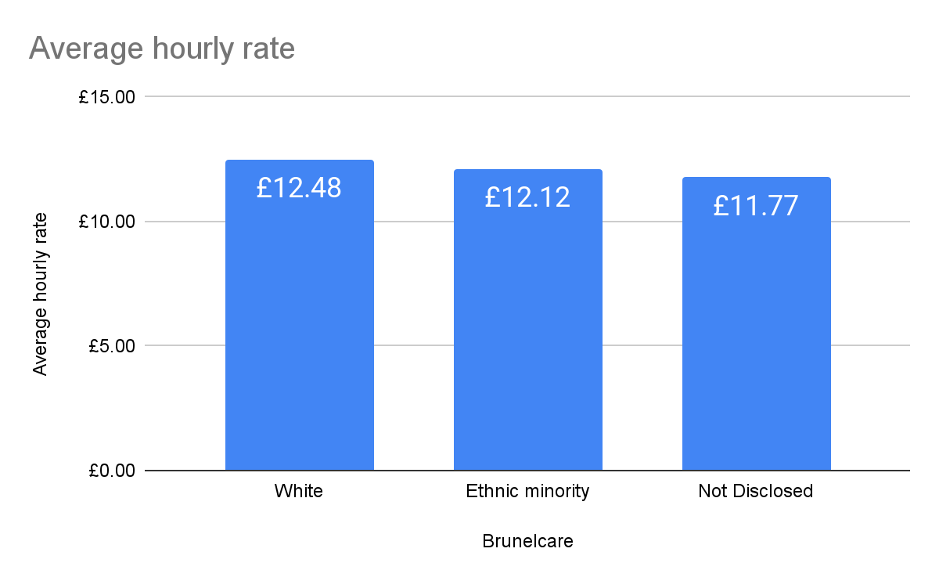

Brunelcare | Average hourly rate
White | £12.48 | 100.0%
Ethnic minority | £12.12 | 97.1%
Not Disclosed | £11.77 | 94.3%

As with our Gender Pay reporting, it is helpful to identify the distribution of each group across four quartiles, from the lowest rates of pay through to the highest.

The distribution of pay rates for Brunelcare are as follows:

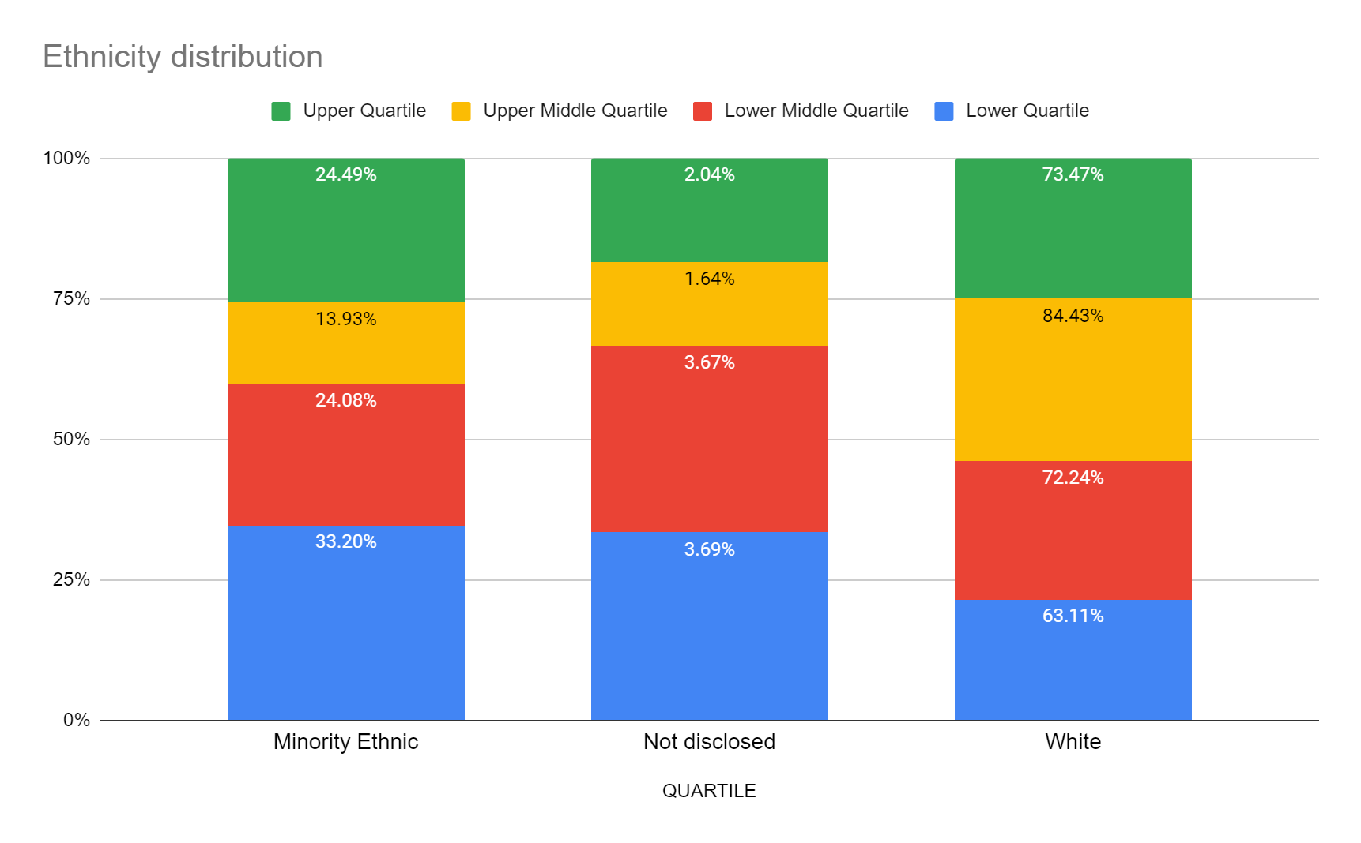
The data for the above chart is shown here:

 | Minority Ethnic | Not disclosed | White
Lower Quartile | 33.20% | 3.69% | 63.11%
Lower Middle Quartile | 24.08% | 3.67% | 72.24%
Upper Middle Quartile | 13.93% | 1.64% | 84.43%
Upper Quartile | 24.49% | 2.04% | 73.47%

Conclusion

There is no indication of an obvious concern in regard to the Brunelcare ethnicity pay gap. The average rate of pay for those who identify as an ethnic minority is 97.1%, which is 2.9% lower than the same calculation for those declaring themselves as white.

It is clear that reducing the number of ‘Not Disclosed’ results (now down to 27 from 693 in 2022) has greatly enhanced the validity of these figures and that will continue to be the focus over the next twelve months.

The ethnicity gap overall has widened over the last year by 4.6% to 2.9% (ethnic minority pay rates were 1.7% higher in 2022), this will have been influenced by our much improved data collection, continued focus on recruiting overseas nurses and carers and also our activities to attract applications from all communities across Bristol and the South West.

