GENDER PAY GAP 2022/23

About Brunelcare
Established in 1941, Brunelcare is a Bristol based charity providing high quality housing, care and support for later living in the South West.
Today, across Bristol, South Gloucestershire and Somerset, Brunelcare works to support over 2,000 people to remain as independent as possible, for as long as possible.
Care is provided in people’s own homes, in specialist care homes and our three reablement facilities.
Housing is provided by 1,150 properties, across 33 sites, three extra care housing sites and a retirement village.
To deliver all of its vital services Brunelcare employs a dedicated team of around 1,000 people.
The extensive range of our services means that people can stay with us however their needs may change.
We are also widely recognised for our expertise and excellence in caring for people living with dementia and for supporting their families.

What is a gender pay gap?

Since April 2017 all companies with 250 or more employees have been required to publish their gender pay gap. A gender pay gap is the difference between the gross hourly earnings for both men and women regardless of the roles that they have. It is very different to equal pay, which is about making sure men and women are paid the same in roles of equal value.

This report shows the average pay gap in Brunelcare between men and women, expressed as both a mean and a median average.

The numbers
The total number of employees that form the basis of this report is 978.

Of the employees involved, 82.5% are female and 17.5% are male, this is effectively unchanged since the previous published results.

All roles within Brunelcare are graded, this means that each position has a defined salary range based on the job content. This is consistently applied without reference to gender.

Our average mean pay gap is 14.99%; this is lower than the previous year by 2.49% and indicates that the number of males holding higher paid roles overall has decreased slightly.

Our average median pay gap is 4.17% which is 3.65% lower than the previous year and it remains below the national figure of 14.3% in 2023. (source).

The figures are shown within the graph below:

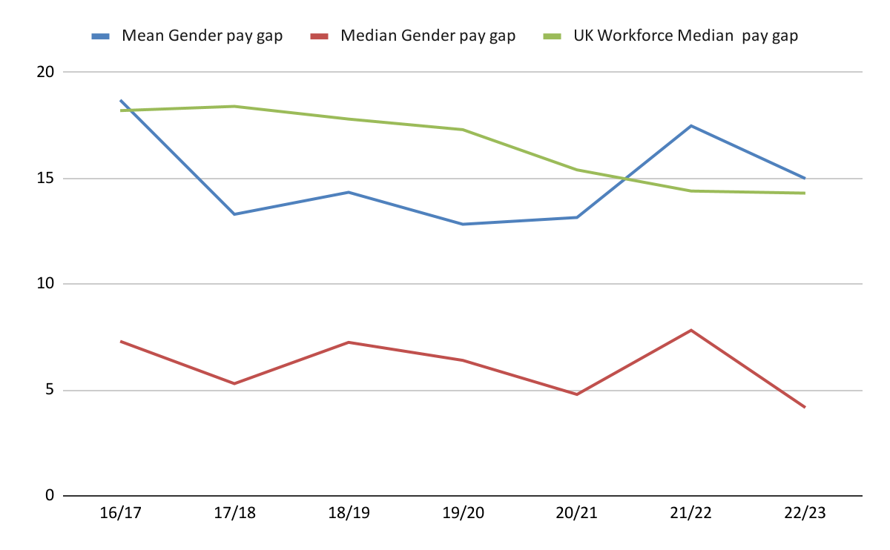

The following comparison shows the allocation by gender across four pay ranges, it can be noted that the percentage of males within the two lower bands has increased slightly, this explains the pay gap decrease:

 | 2022/23
 | Lower Quartile | Lower Middle Quartile | Upper Middle Quartile | Upper Quartile
Male | 14.8% | 14.3% | 13.9% | 26.9%
Female | 85.2% | 85.7% | 86.1% | 73.1%
 | 2022/23 - difference from 21/22
 | Lower Quartile | Lower Middle Quartile | Upper Middle Quartile | Upper Quartile
Male | 1.0% | 4.8% | -0.7% | 0.5%
Female | -0.6% | -4.5% | 0.7% | -0.5%

We also publish our mean and median bonus gaps annually, this is not the total bonus paid but rather the average value of bonuses paid to each gender. It can be noted that the mean bonus gap has fallen to -4.05% for the year up to March 2023 meaning that bonuses awarded to female colleagues were 4% higher than those awarded to male colleagues.

Mean Bonus Gender Pay Gap | 2023 | 2022 | Median Bonus Gender Pay Gap | 2023 | 2022
Male | £ 374.39 | £ 378.55 | Male | £ 200.00 | £ 258.87
Female | £ 389.55 | £ 370.42 | Female | £ 200.00 | £ 200.00
 | -4.05% | 2.15% |  | 0.00% | 22.74%

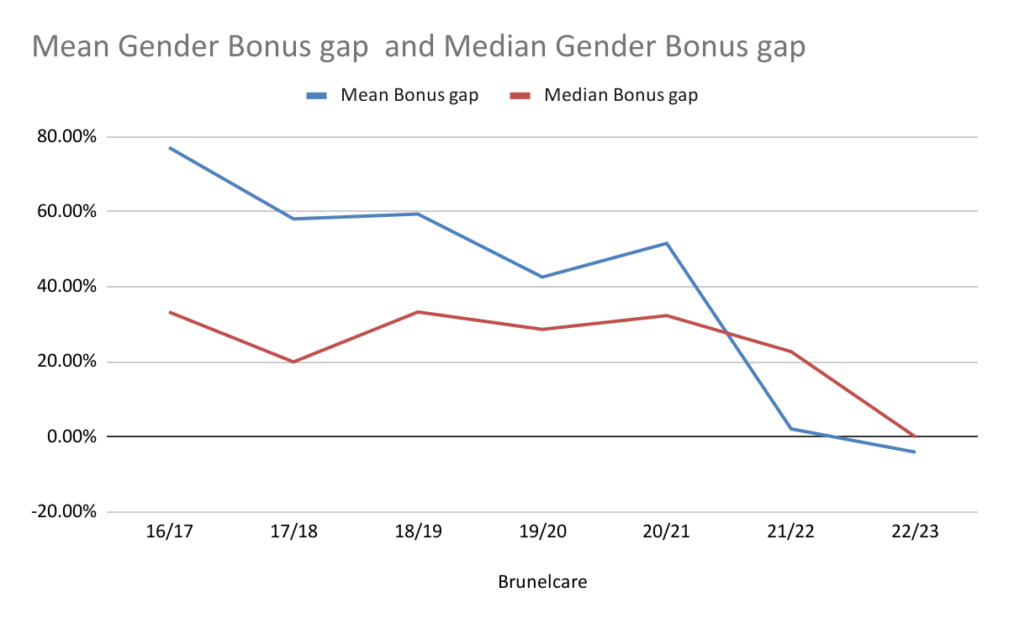

We also track how many people (by gender) receive a bonus in the year, this is expressed in the graph below. It should be noted that the values are percentages showing that in 2022/23, approximately one fifth of employees were paid a bonus (in both genders).

The spike shown for 2019/20 reflects the payment of a bonus to all employees as a thank you for their extraordinary efforts through the first COVID lockdown.

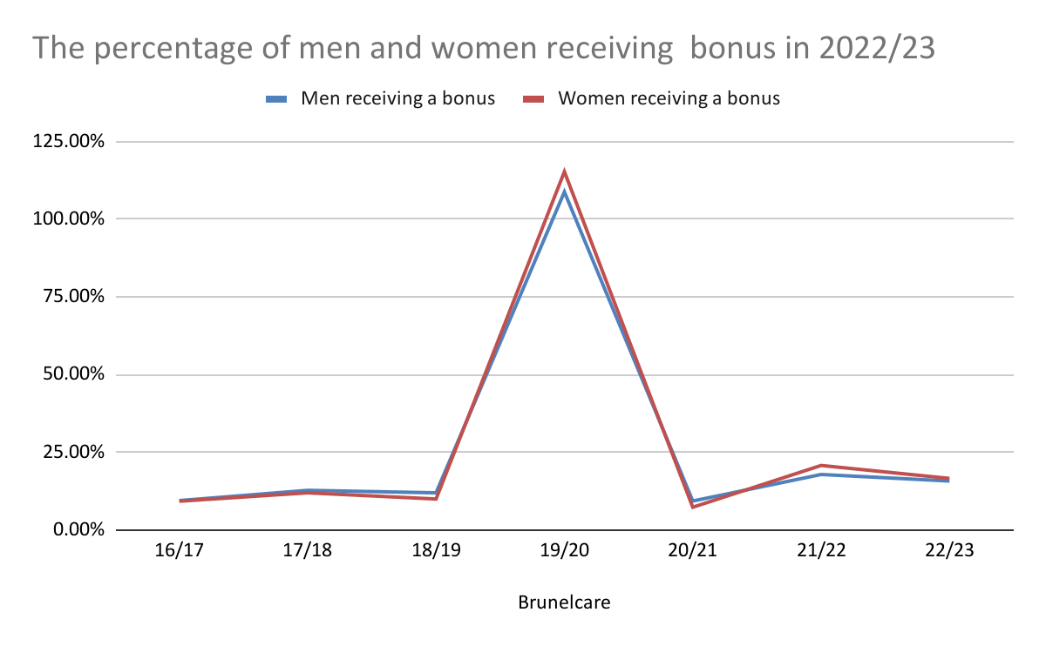
Brunelcare aims to treat everyone fairly at work, across all levels and locations. This includes making sure everyone has the same opportunities for recognition, reward and career development. Because of our pay grading system, we know that we provide men and women with equal pay for the roles they hold.

We are committed to ensuring that leadership positions are available to the widest pool of talent regardless of gender. We are proud that our leadership team has an excellent gender balance; of our six executives, four are female including our Chief Executive.

We are equally proud that out of the 245 highest paid employees across Brunelcare, 73.06% are female.

Brunelcare is committed to delivering equality of opportunity regardless of gender and has a pay and grading structure to support this. We remain determined to ensure that our gender pay gap reflects the reality of our organisation and can be explained in full.
We believe that we are successfully delivering equality both in terms of equal pay and also in rewarding roles of equal value.
The full suite of data is provided below:

Brunelcare | 16/17 | 17/18 | 18/19 | 19/20 | 20/21 | 21/22 | 22/23
Mean Gender pay gap | 18.7% | 13.3% | 14.34% | 12.83% | 13.15% | 17.48% | 14.99%
Median Gender pay gap | 7.3% | 5.3% | 7.25% | 6.40% | 4.79% | 7.82% | 4.17%
UK Workforce Median pay gap | 18.20% | 18.40% | 17.80% | 17.30% | 15.40% | 14.40% | 14.30%
Brunelcare | 16/17 | 17/18 | 18/19 | 19/20 | 20/21 | 21/22 | 22/23
Mean Bonus gap | 77.12% | 58.10% | 59.40% | 42.60% | 51.59% | 2.15% | -4.05%
Median Bonus gap | 33.30% | 20.00% | 33.30% | 28.67% | 32.34% | 22.74% | 0.00%
The large gap from 2017 to 2021 was due to one male employed on a commission basis, hence his salary was coded to 'bonus'.
Brunelcare | 16/17 | 17/18 | 18/19 | 19/20 | 20/21 | 21/22 | 22/23
Men receiving a bonus | 9.50% | 12.80% | 12.00% | 108.80% | 8.77% | 17.90% | 15.79%
Women receiving a bonus | 9.30% | 12.00% | 10% | 115.30% | 7.36% | 20.80% | 16.63%

Allocation by quartile:
